FIRE ESCAPE PLAN
Draw a floor plan of your house in the box below to show how you would exit in case of an emergency or fire.  Draw a line from your bedroom to at least two exits from your house, for example, the front door or side door to a meeting place.  Ask your parents to help you plan and practice the safety route together.  Draw where the smoke alarms and the fire extinguishers are located in your house. | 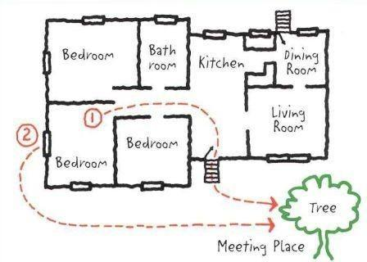

Other tips for fire safety:
- Get out of the house as soon as possible. Don’t take anything with you when leaving the house.
- If your clothes catch on fire, don’t run. Stop, Drop and Roll on the ground to put the fire out.
- If there is a lot of smoke, crawl on the floor. The air is less smoke-filled near the floor.
- If there is a fire dial 999 from outside the house using either a mobile phone or from a neighbour’s house.
- Check smoke alarms are working and change batteries regularly.

